LOAD BALANCER

- Configure Classic Load balancer.

Task Title
Configure and Test a Classic Load Balancer (CLB) in AWS With Multiple EC2 Instances

Objective
To create a Classic Load Balancer that distributes incoming HTTP traffic across EC2 instances deployed in multiple Availability Zones, ensuring high availability and fault tolerance.

Prerequisites
- An AWS account with required IAM permissions.
- A VPC with:
  - Public and private subnets (us-east-1a, us-east-1b).
  - An Internet Gateway attached.
- Two EC2 instances running:
  - Public-EC2 (public subnet)
  - Private-LB (private subnet)
- A security group allowing inbound HTTP (port 80).
- Simple web pages configured on each instance:
  - Instance 1 → "WELCOME TO INDIA"
  - Instance 2 → "hello, you’re looking beautiful"

1. Create Classic Load Balancer
- Open EC2 Console → Load Balancers → Create Load Balancer → Classic Load Balancer.
- Enter name: classic-LB.
- Choose Scheme: Internet-facing.

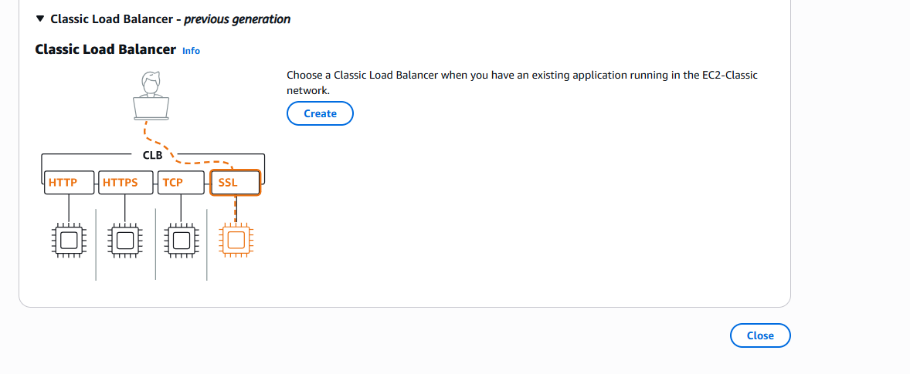
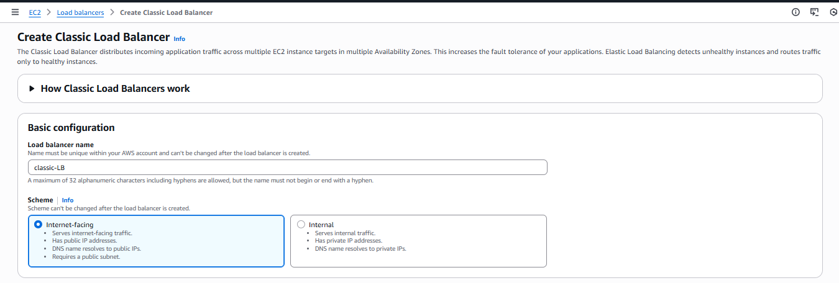

2. Configure Network Mapping
- Select your VPC: my-vpc (vpc-05f8bba...d889).
- Enable these subnets:
  - us-east-1a (public-subnet)
  - us-east-1b (private-LB)
- AWS shows a warning for the private subnet (no IGW route).
✔ This is acceptable because the CLB only needs public subnet in the AZ to be reachable.

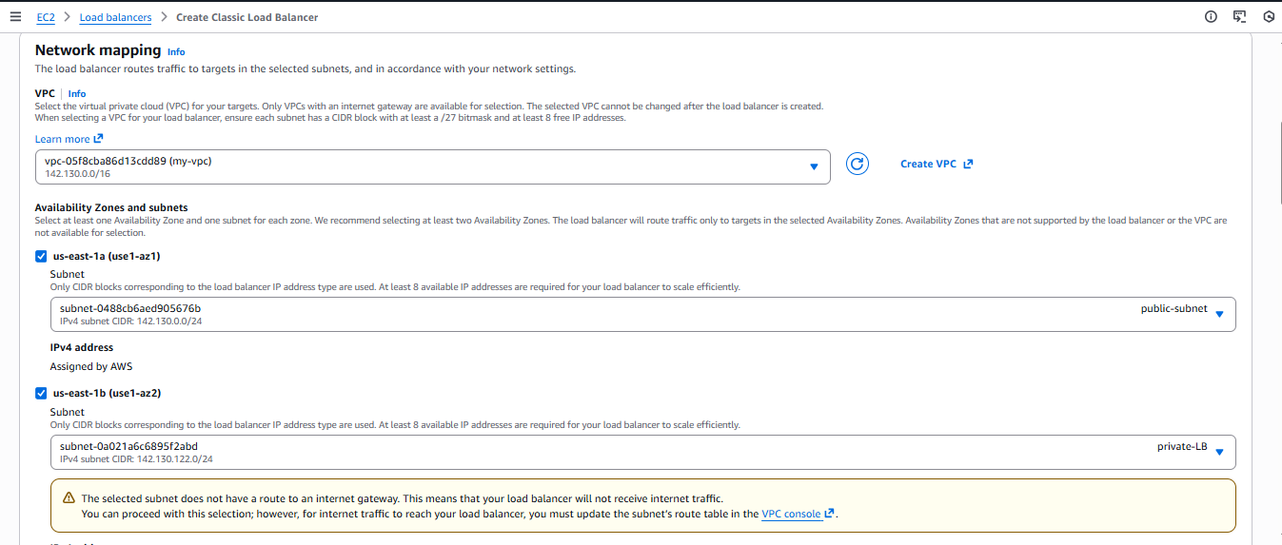

3. Security Group
- Select existing SG: NewSG
  - Inbound Rule: HTTP (80) from Anywhere.

4. Listeners and Routing
- Listener configuration:
  - Load Balancer Protocol: HTTP → Port 80
  - Instance Protocol: HTTP → Port 80

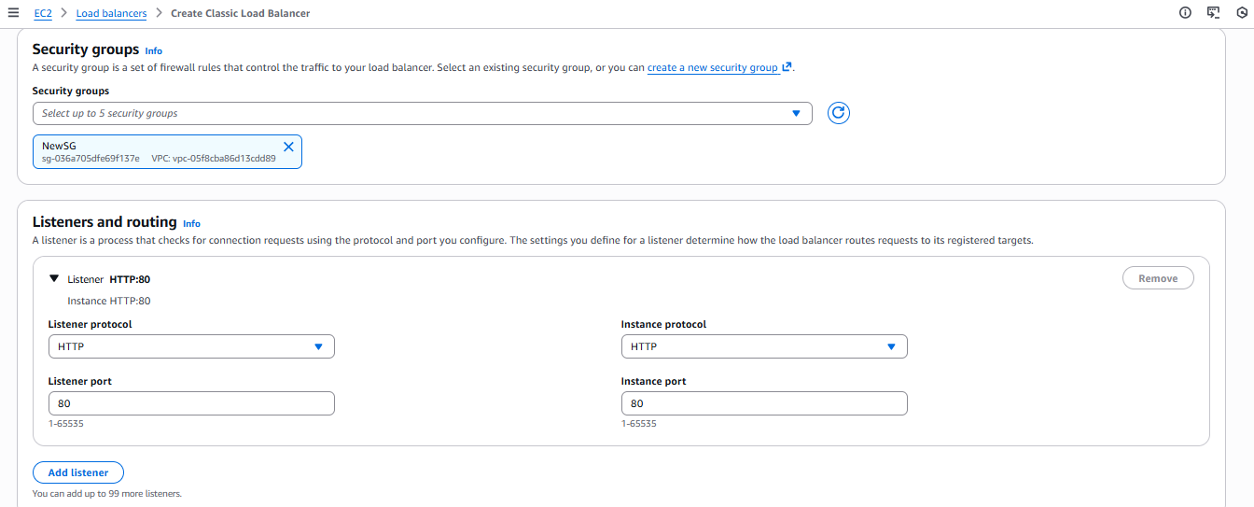

5. Health Checks
Default health check configuration:
- Protocol: HTTP
- Ping Path: /
- Timeout: 5 seconds
- Interval: 30 seconds
- Unhealthy threshold: 2
- Healthy threshold: 10

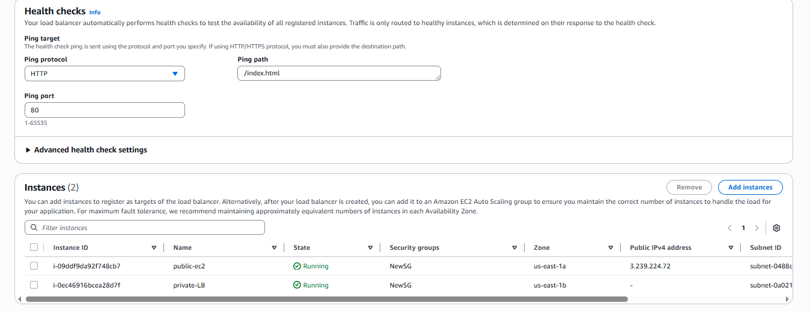

6. Enable Attributes
- ✔ Cross-zone load balancing
- ✔ Connection draining (timeout 300 seconds)

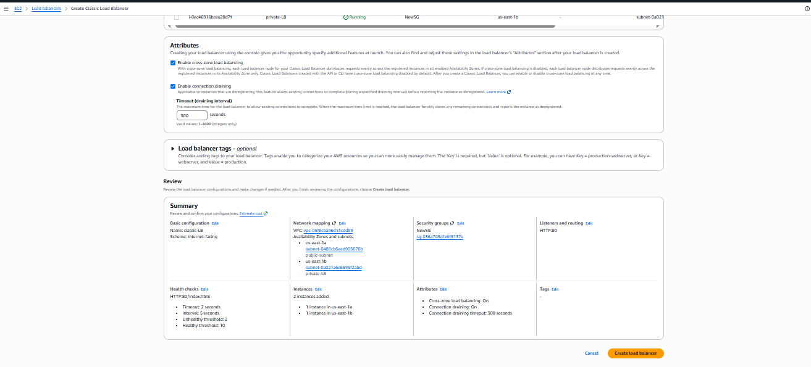

7. Register Instances
Add:
- public-ec2
- private-LB
Both change status from OutOfService → InService after health checks pass.

8. Review and Create
Click Create Load Balancer.
The CLB DNS name is generated, e.g.:
classic-lb-1995953407.us-east-1.elb.amazonaws.com

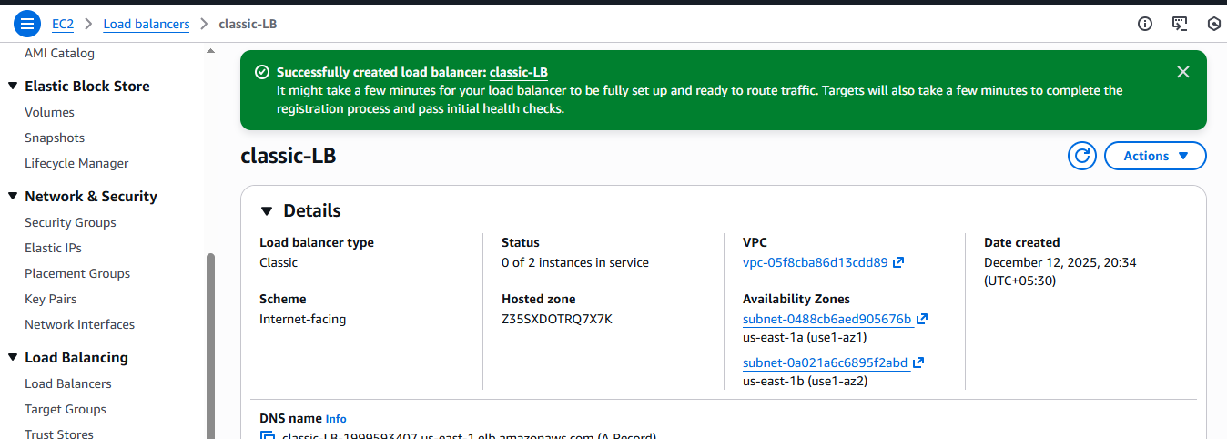
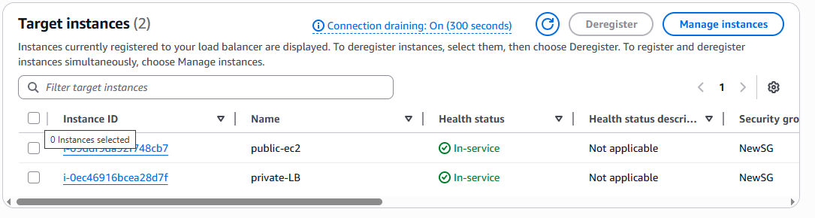

Validation Steps

1. Test Load Balancer in Browser
Open:
http://classic-lb-1995953407.us-east-1.elb.amazonaws.com

Expected Output (Round-Robin):
Request 1 → Instance 1
WELCOME TO INDIA
Request 2 → Instance 2
hello, you're looking beautiful
You confirmed this behavior in your screenshots — traffic was successfully balanced across instances.

Issues Faced

⚠ 1. Private subnet warning
AWS warned that the private subnet does not have a route to the Internet Gateway.
✔ This is normal and expected — the load balancer can still route traffic because the LB node exists in the public subnet.

⚠ 2. Instance initially showing “Initializing”
EC2 health checks momentarily caused the instance to display initializing state.
✔ Resolved automatically after health checks passed.

Conclusion
The Classic Load Balancer was successfully created and configured to distribute HTTP traffic across EC2 instances in two Availability Zones. Both instances were registered as “InService”, and the CLB routed requests in a round-robin fashion, verified through distinct webpage outputs from each instance. This setup ensures improved availability, fault tolerance, and balanced traffic distribution across instances.

- Configure Application Load balancer.

Task Title
Create and Configure an Application Load Balancer (ALB) to Distribute Traffic Across EC2 Instances

Objective
To design and deploy an Application Load Balancer that distributes HTTP traffic across multiple EC2 instances, ensuring high availability, fault tolerance, and proper health monitoring.

Prerequisites
- AWS account with EC2 and ELB permissions
- Existing VPC with at least two subnets
- Internet Gateway attached to the VPC
- EC2 instances running a web server (Apache/httpd)
- Security Group allowing inbound HTTP (port 80)
- Basic understanding of EC2, VPC, and Load Balancers

Step-by-Step Implementation
- Launch EC2 Instances
  - Created EC2 instances in different subnets
  - Installed and started Apache web server
  - Configured unique index pages for verification

Create Application Load Balancer
- Selected Internet-facing ALB
- Assigned VPC and subnets
- Attached appropriate security group

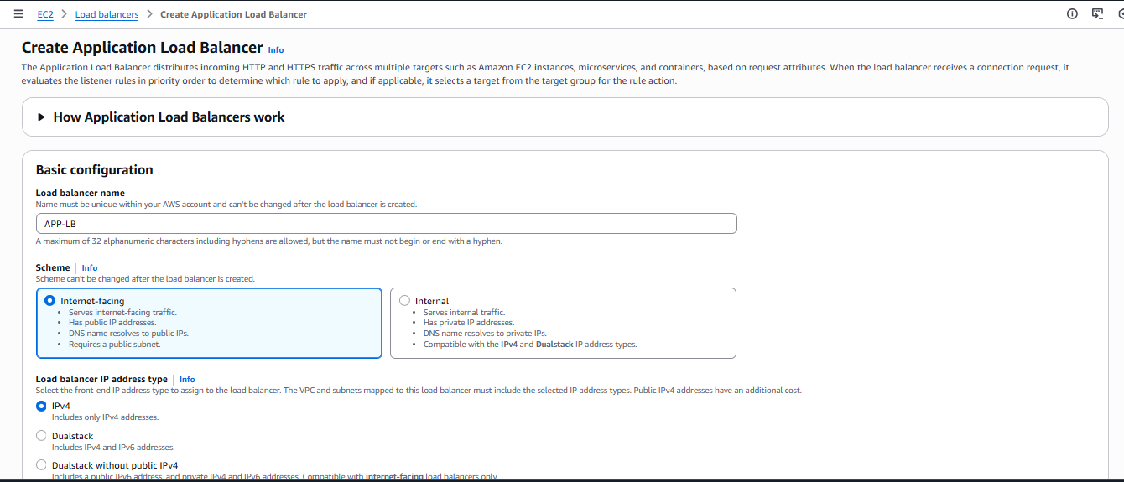
Configure Listener
- Protocol: HTTP
- Port: 80
- Default action: Forward to target group

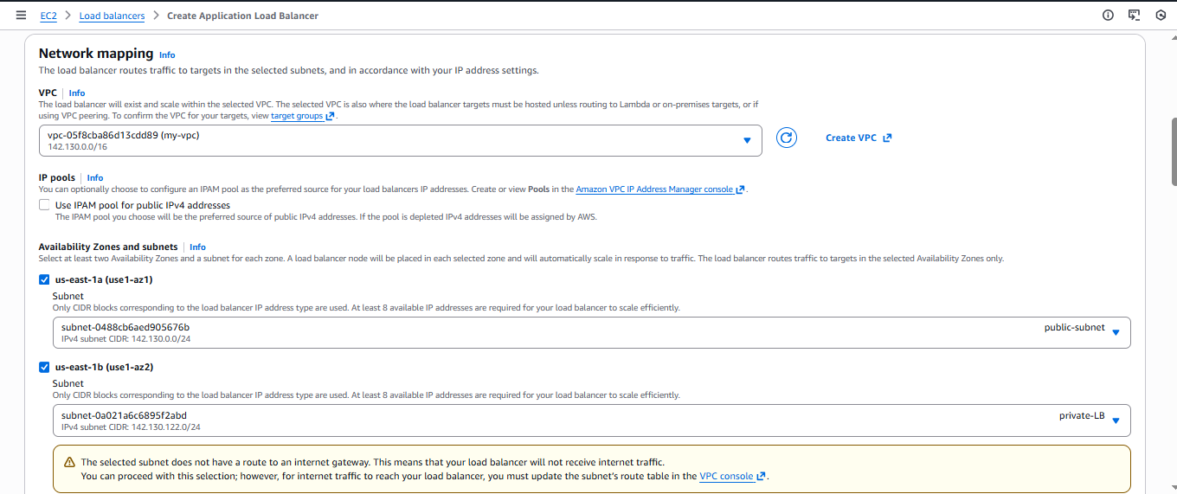
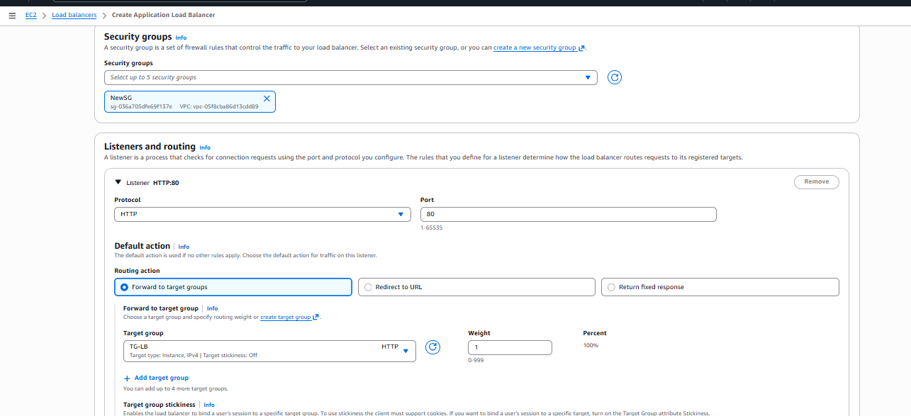
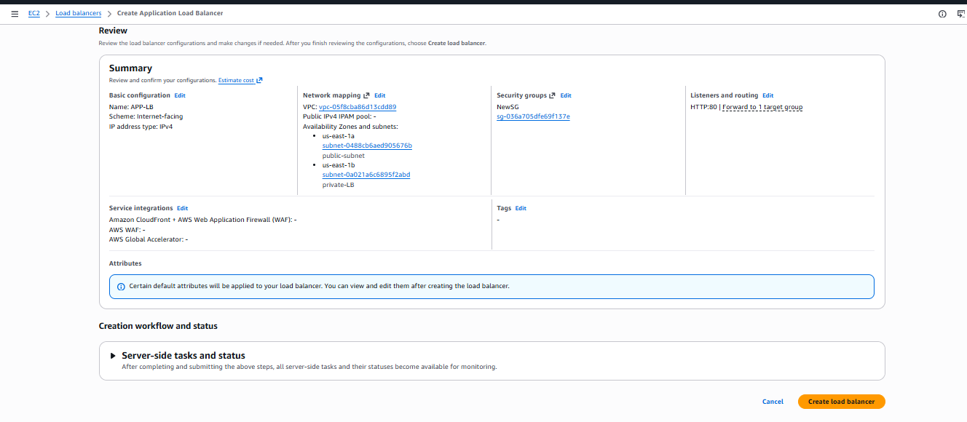
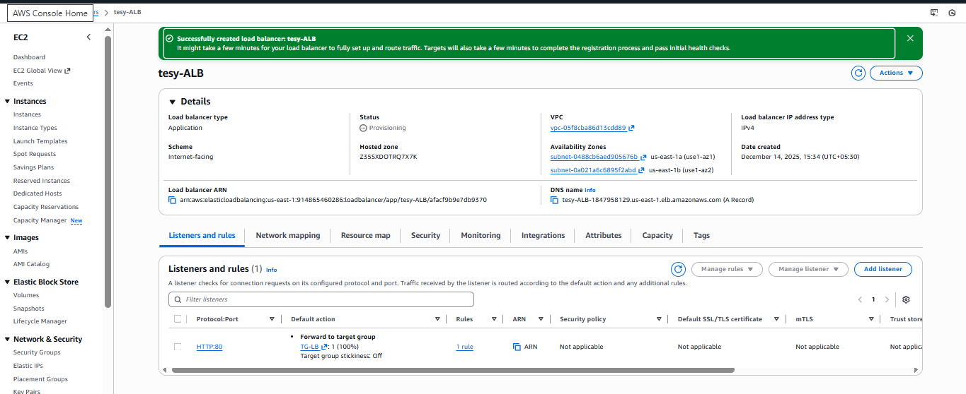
Create Target Group
- Target type: Instance
- Protocol: HTTP
- Port: 80
- Registered EC2 instances
- Verified health check status

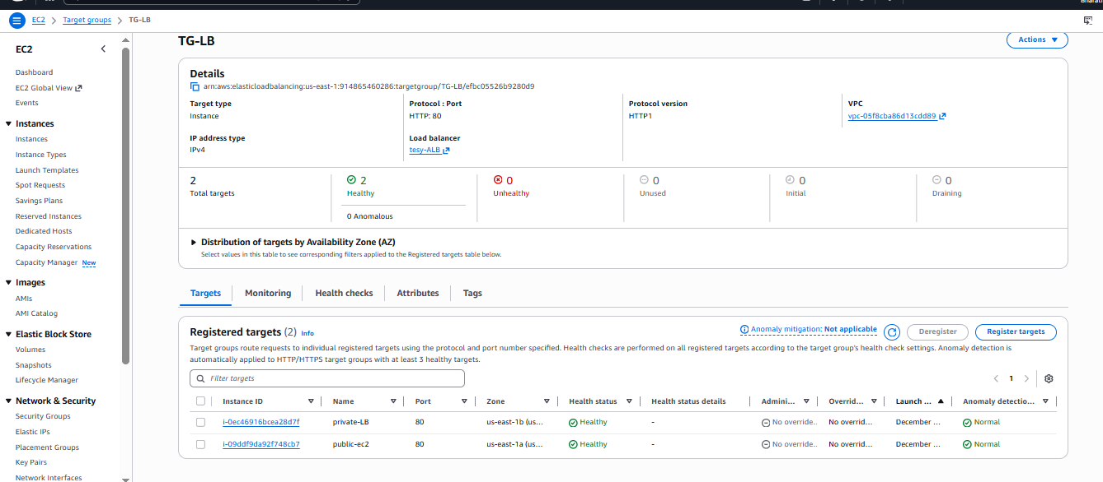
Verify Load Balancer
- Waited for targets to become healthy
- Accessed ALB DNS name via browser




Validation Steps
- ALB status shows Active
- Target group displays Healthy EC2 instances
- Accessing ALB DNS name loads web page
- Page content changes on refresh, confirming load distribution

Issues Faced
- One subnet lacked a route to Internet Gateway
- Initial unhealthy targets due to missing HTTP rule in security group
- Delay in target health check registration

Conclusion
The Application Load Balancer was successfully deployed and configured to distribute HTTP traffic across multiple EC2 instances. The setup ensures high availability, improved reliability, and effective traffic management. This implementation follows AWS best practices and is suitable for scalable web applications.

3.Configure Network Load balancer.

Task Title
Implementation of AWS Network Load Balancer (NLB) with EC2 Target Group.

Objective
To create and configure an AWS Network Load Balancer (NLB) that distributes TCP traffic on port 80 across multiple EC2 instances, ensuring high availability, low latency, and reliable request handling.

Prerequisites
- AWS account with required IAM permissions
- Existing VPC with:
  - At least two subnets in different Availability Zones
- Running EC2 instances with web servers configured on port 80
- Security Group allowing inbound TCP 80
- Basic understanding of AWS EC2, Target Groups, and Load Balancers

Create Target Group
- Navigate to EC2 → Target Groups → Create target group
- Select:
  - Target type: Instance
  - Protocol: TCP
  - Port: 80
  - VPC: Select your VPC
- Configure Health Checks:
  - Protocol: TCP
  - Port: traffic-port
- Register EC2 instances to the target group
- Create the target group and verify targets show Healthy

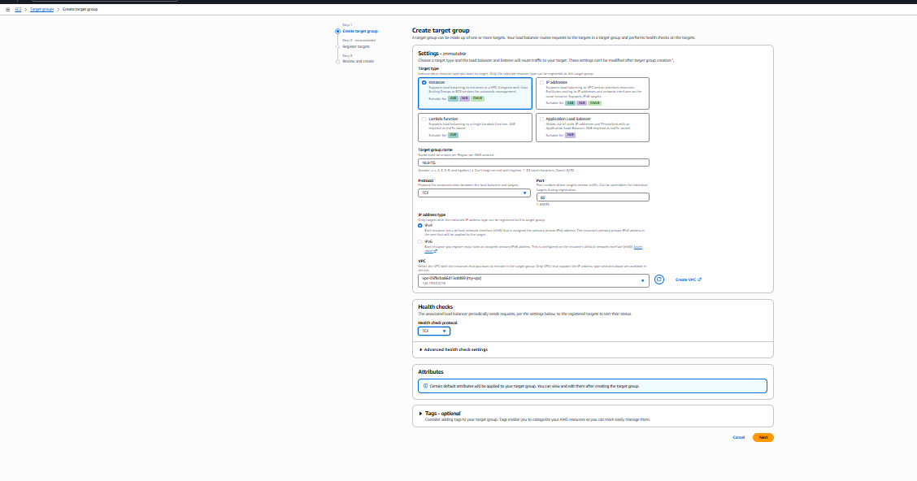
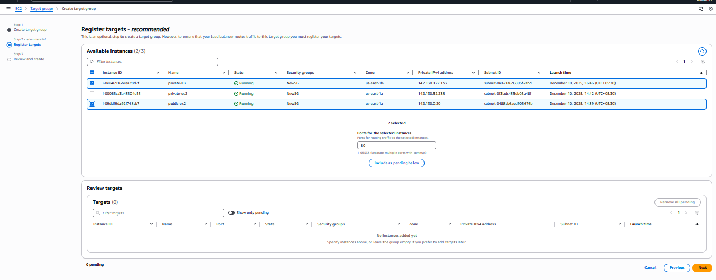
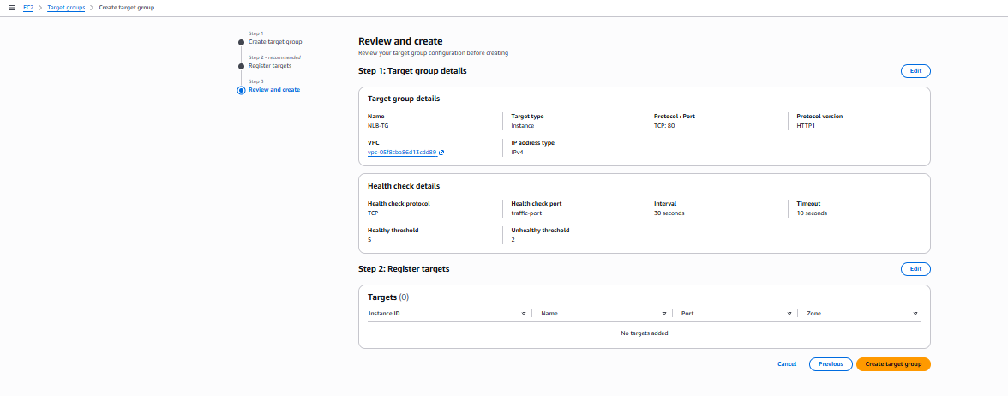

Verify Target Registration
- Navigate to the Target Group
- Confirm EC2 instances are:
  - Registered
  - Showing Healthy status

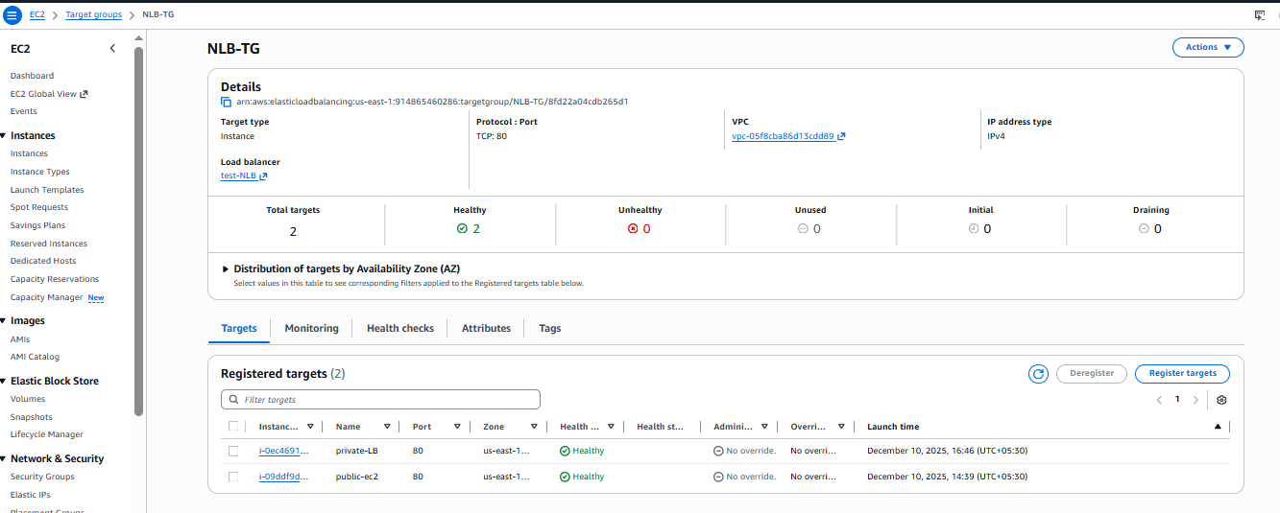

Create Network Load Balancer
- Go to EC2 → Load Balancers → Create Load Balancer
- Select Network Load Balancer
- Configure basic settings:
  - Name: test-NLB
  - Scheme: Internet-facing
  - IP address type: IPv4
- Configure Network Mapping:
  - Select VPC
  - Choose subnets from at least two Availability Zones
- Configure Listeners:
  - Protocol: TCP
  - Port: 80
- Forward traffic to the previously created Target Group
- Review and create the load balancer

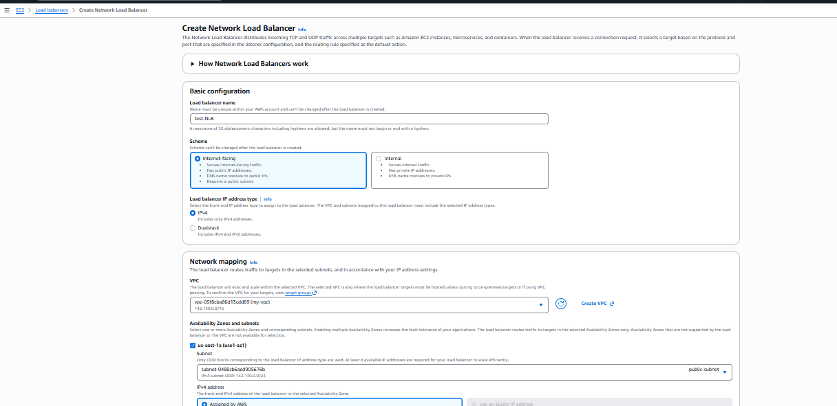
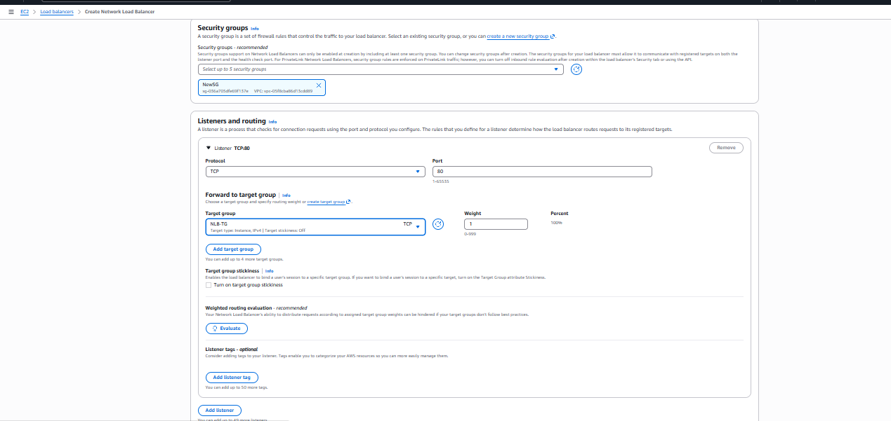
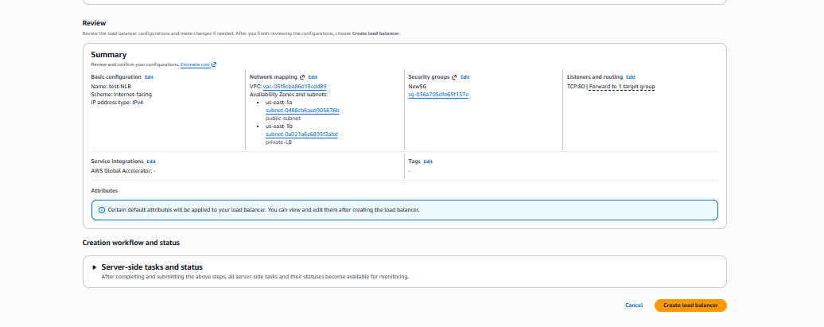
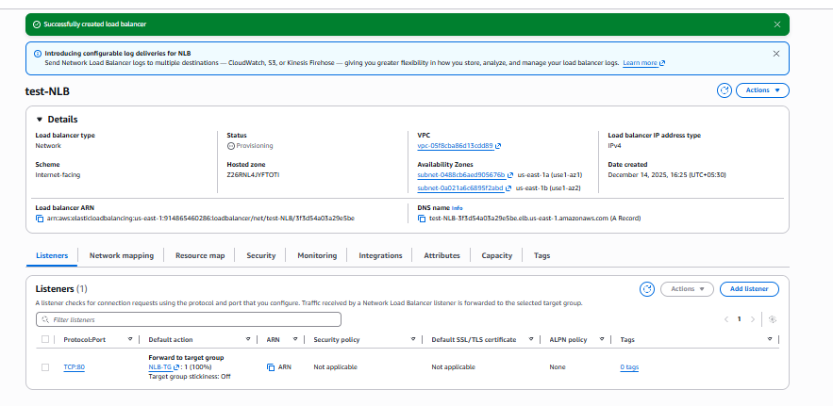




Validation Steps
- Copy the NLB DNS name
- Access it via browser:
- http://<NLB-DNS-Name>
- Refresh the page multiple times
- Verify traffic is routed to different EC2 instances by observing:
  - Different webpage content
  - Instance-specific responses
- Check:
  - Target Group health status = Healthy
  - NLB status = Active

Issues Faced
- Target instances initially appeared unhealthy due to missing port 80 access in security groups
- Health check delays while instances transitioned to healthy state
- Subnet selection warnings when route to Internet Gateway was missing
- Delay in DNS propagation after NLB creation

Conclusion
The Network Load Balancer was successfully deployed and configured to distribute TCP traffic across multiple EC2 instances. The setup ensures high availability, scalability, and fault tolerance with minimal latency. All targets were validated as healthy, and traffic routing was confirmed using the NLB DNS endpoint.

4.Attach SSL for application load balancer.
5. Map Application load balancer to R53.

Task Title
Implementation of AWS Load Balancers (CLB, ALB, NLB) with Target Groups and SSL using AWS Certificate Manager

Objective
To design and deploy different types of AWS Elastic Load Balancers (Classic, Application, and Network) to distribute traffic across EC2 instances, validate health checks, and secure application traffic using HTTPS with AWS Certificate Manager (ACM).

Prerequisites
- AWS account with EC2, ELB, Route 53, and ACM access
- VPC with public and private subnets across multiple Availability Zones
- Running EC2 instances with a web server (Apache/NGINX) on port 80
- Security Group allowing inbound HTTP (80) and HTTPS (443)
- A registered domain name and Route 53 hosted zone
- Basic knowledge of AWS networking and load balancing

Launch EC2 Instances
- Created two EC2 instances (public-ec2 and private-ec2)
- Installed web server and configured unique index pages:
  - Instance 1: “WELCOME TO INDIA”
  - Instance 2: “hello, you're looking beautiful”

Request SSL Certificate using ACM
- Requested Public Certificate
- Domain: bharathindustries.online
- Validation method: DNS
- Created CNAME record in Route 53
- Certificate status: Issued

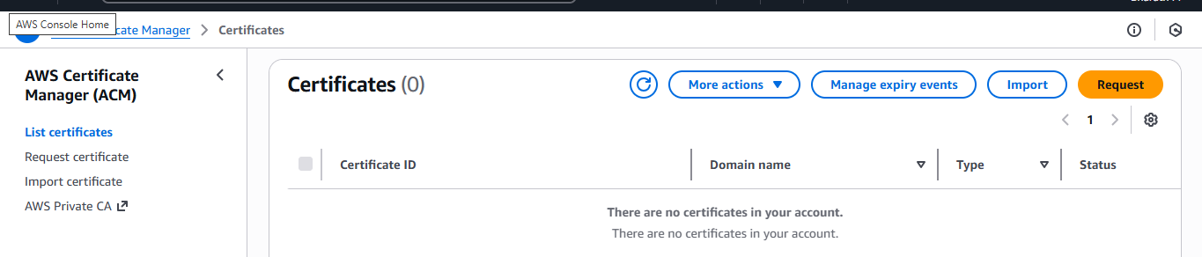
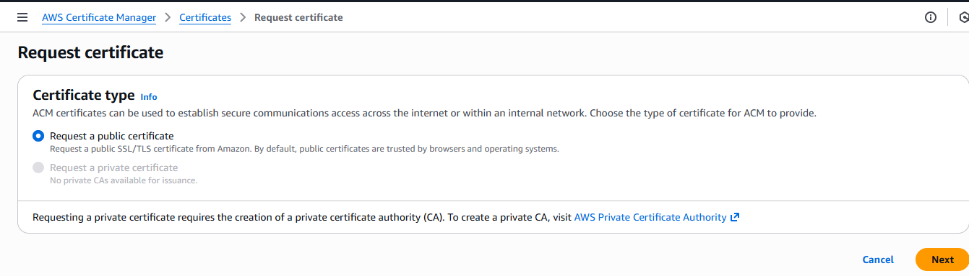
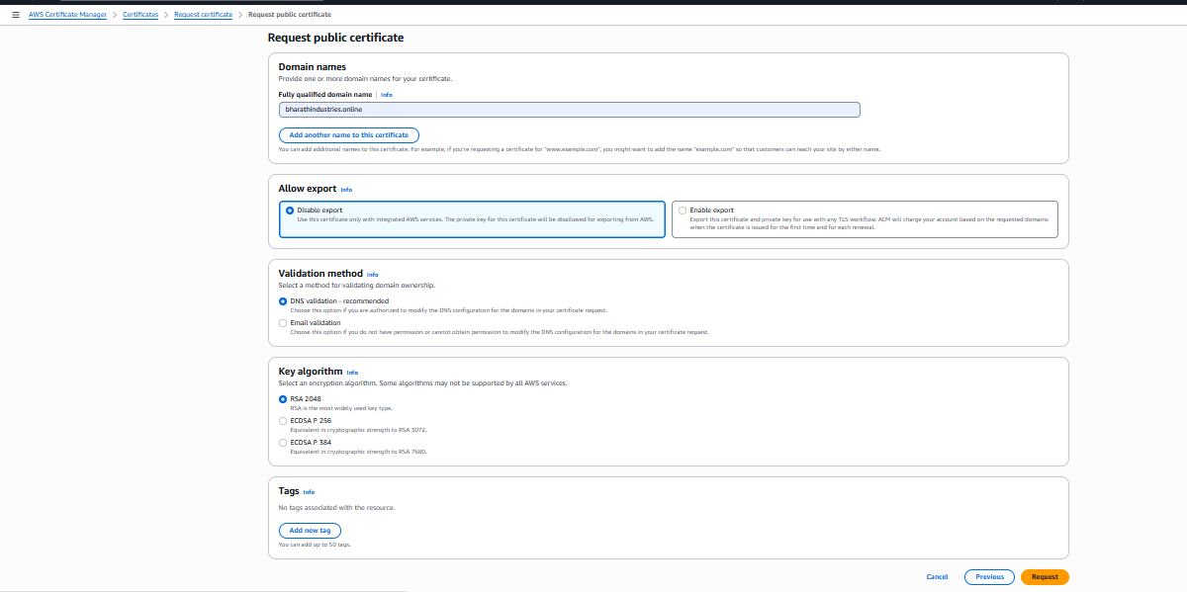
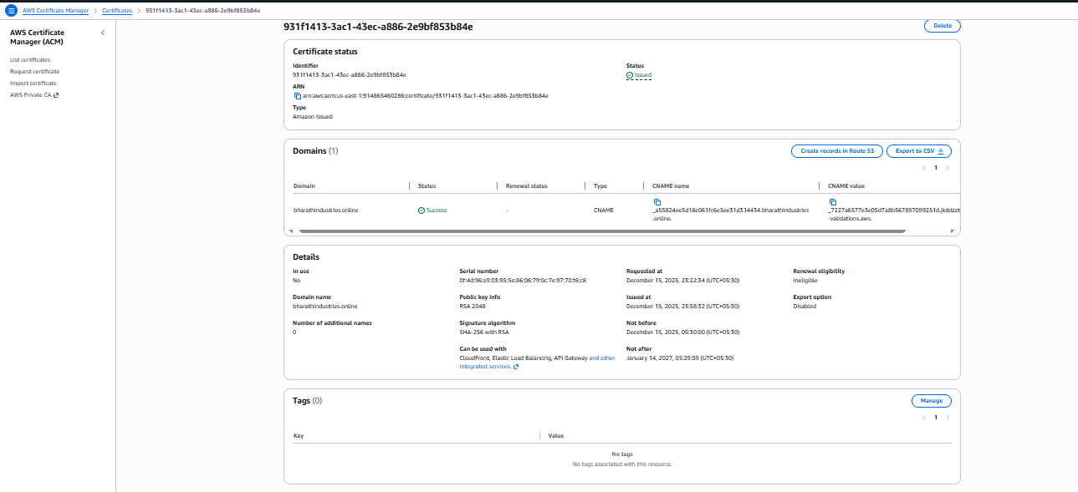
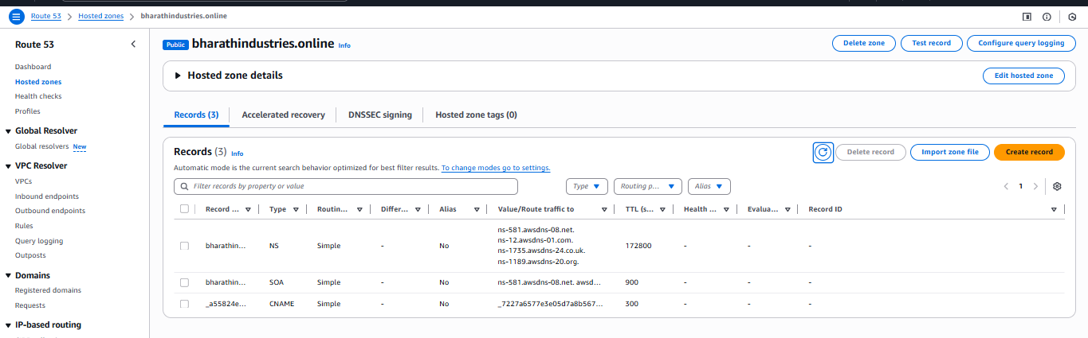
Validated it via Route 53 (DNS validation)
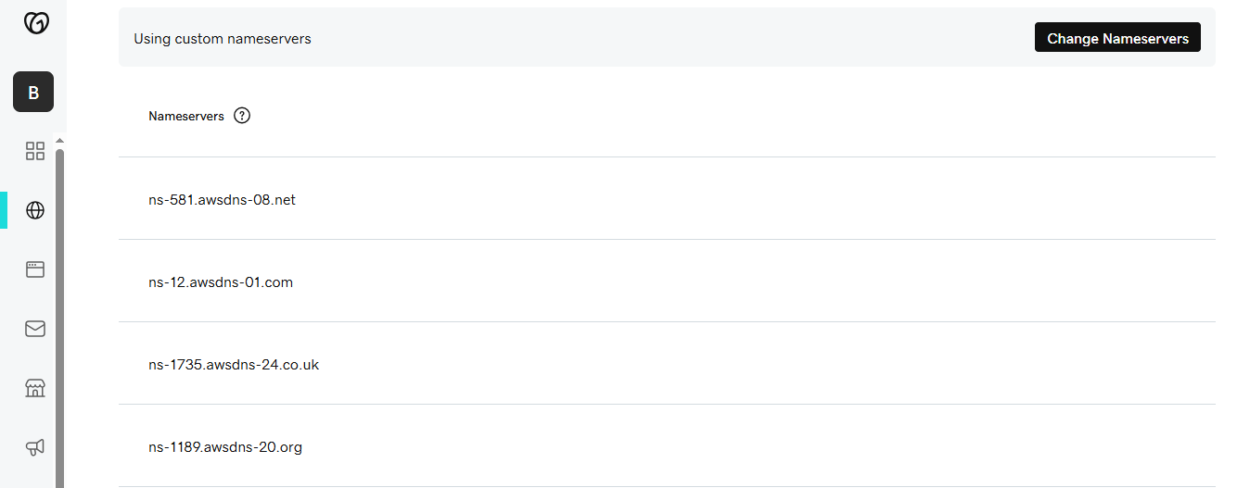

Create Target Groups
- Target type: Instance
- Protocol:
  - ALB → HTTP
  - NLB → TCP
- Health checks enabled
- Verified all targets showing Healthy

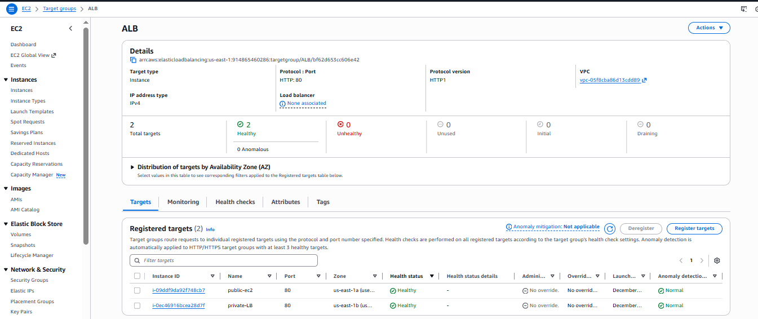

Create Application Load Balancer (ALB)
- Load balancer type: Application
- Scheme: Internet-facing
- Mapped to public subnets in multiple AZs
- Listener:
  - HTTP : 80
- Created Target Group (Instance type)
- Registered EC2 instances
- Verified routing via ALB DNS name

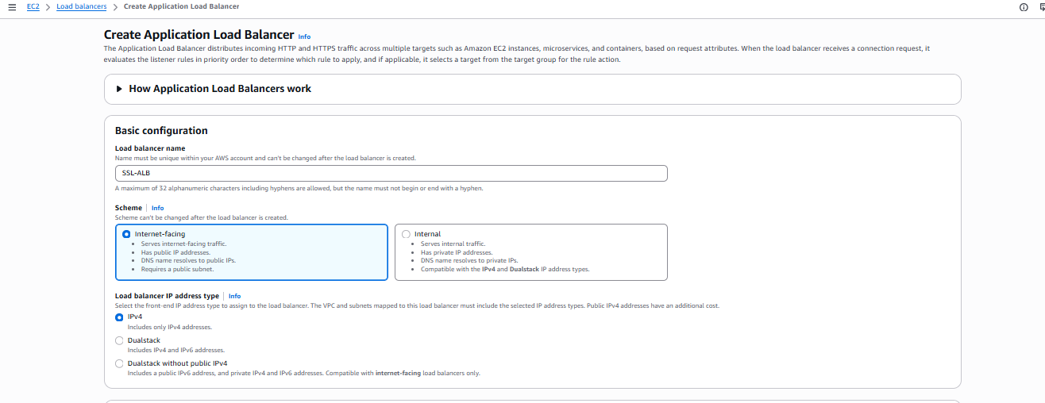

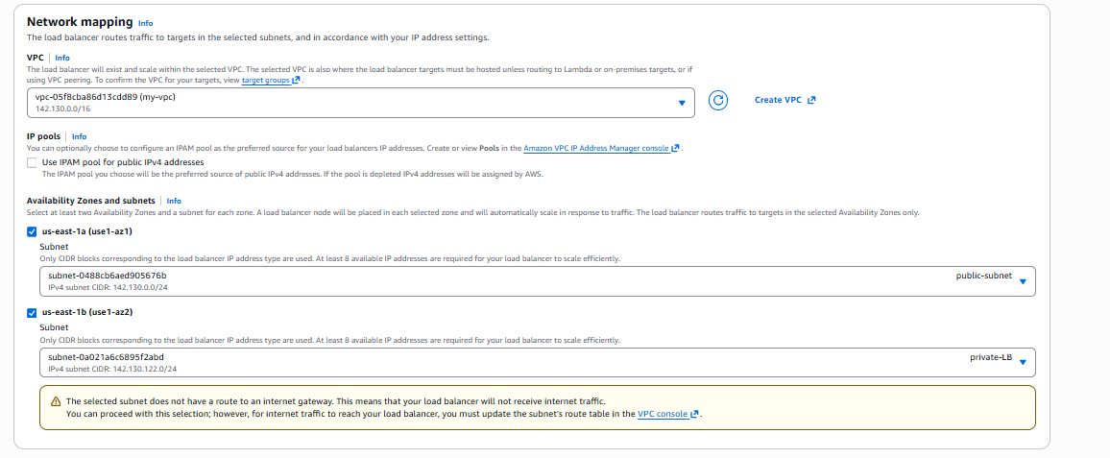
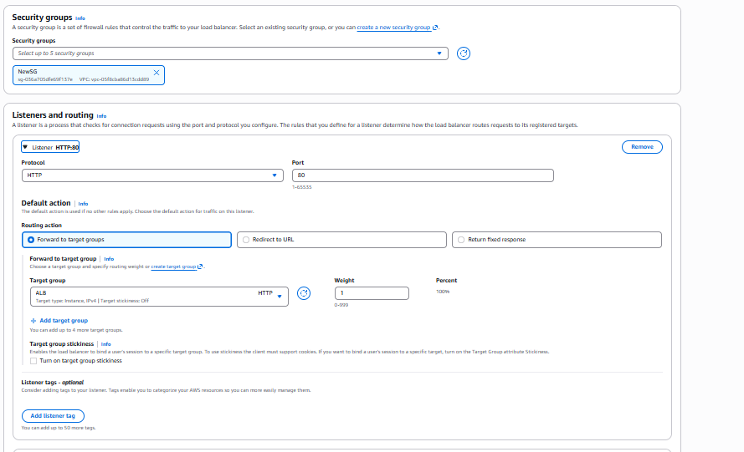
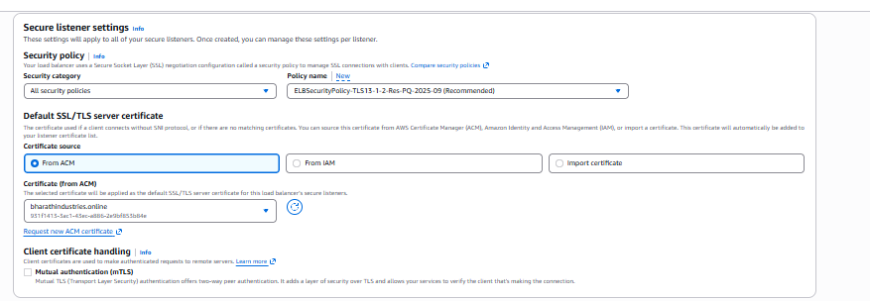

Configure HTTPS on ALB
- Added HTTPS listener (443)
- Attached ACM SSL certificate
- Security policy: AWS recommended
- Forwarded traffic to existing target group
- Verified HTTPS access using domain nam
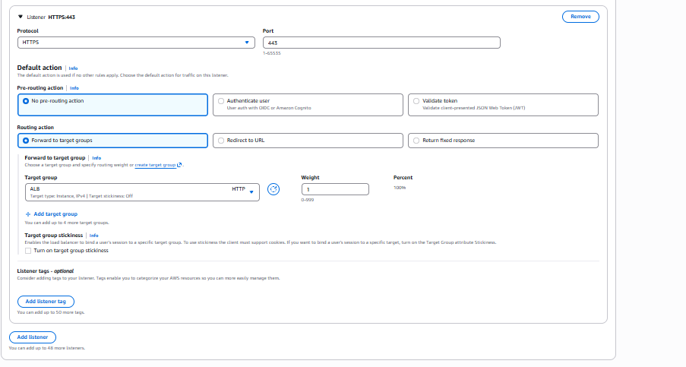
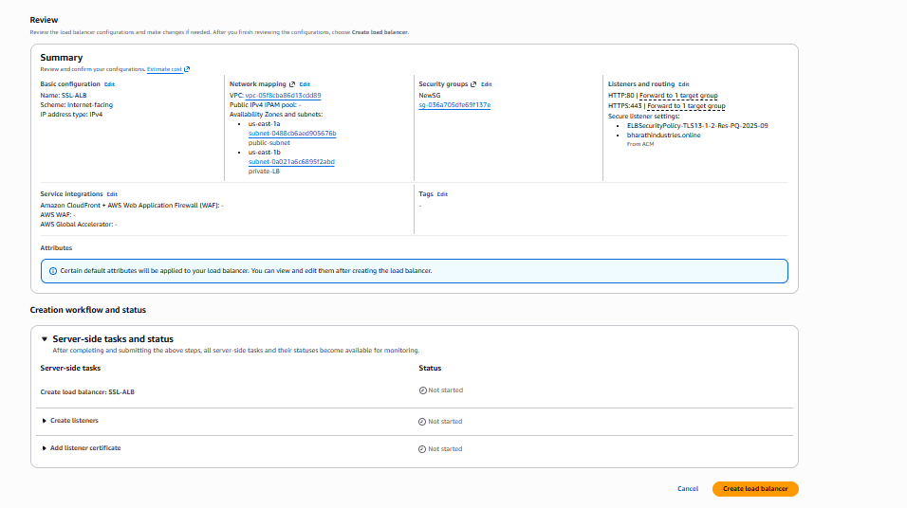

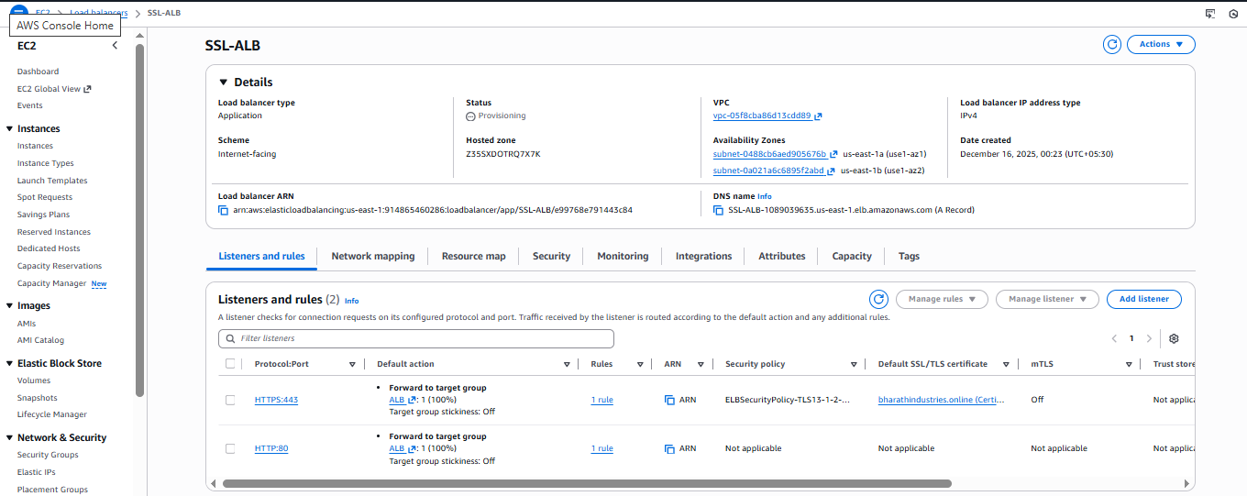
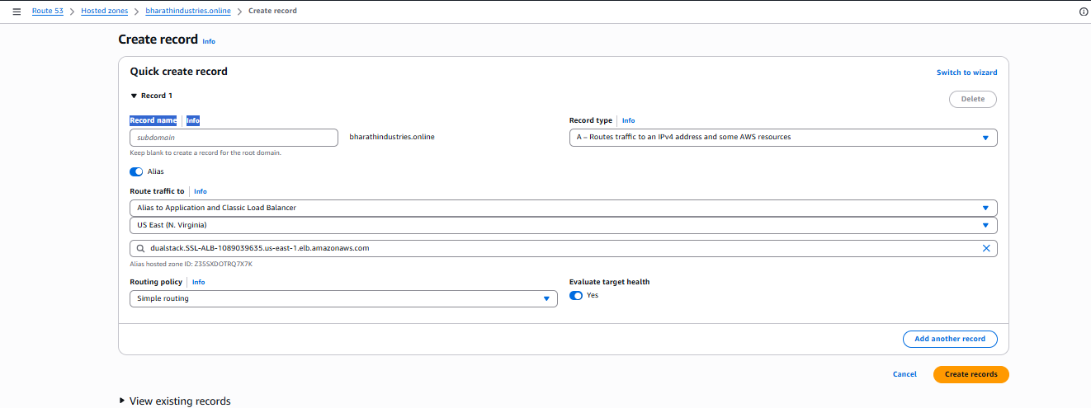

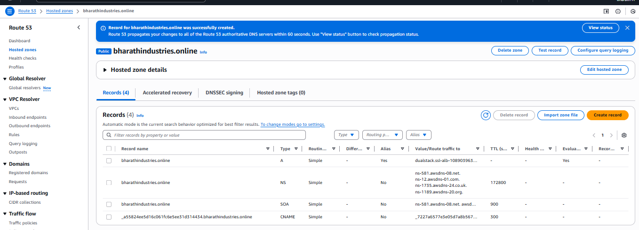

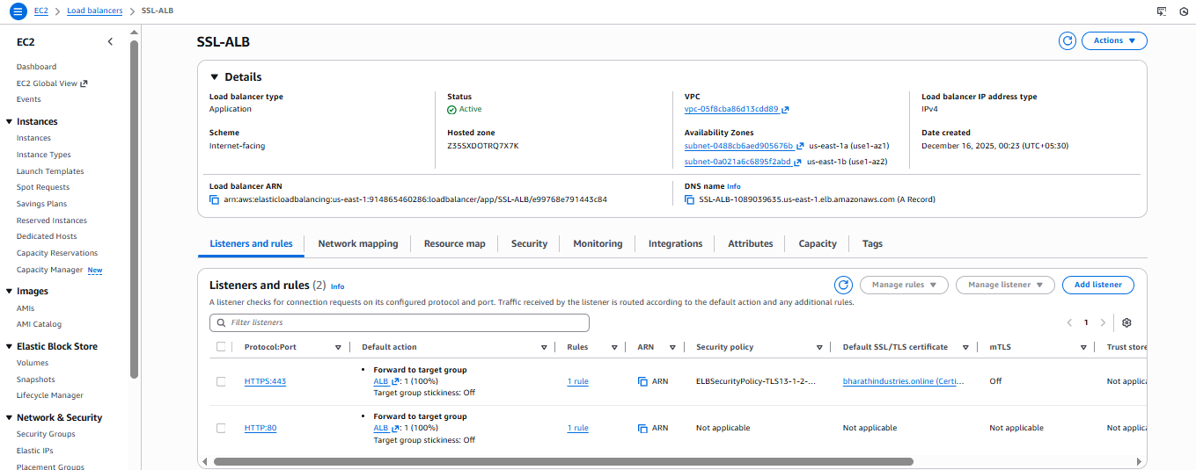





Validation Steps
- Accessed CLB DNS → received responses from both EC2 instances
- Accessed ALB DNS → traffic routed correctly via target group
- Accessed NLB DNS → confirmed TCP-based routing
- Verified target group health checks (Healthy)
- Accessed application using:
  - HTTP → Successful
  - HTTPS (SSL) → Secure connection verified
- Confirmed Route 53 DNS resolution

Issues Faced
- Subnet without Internet Gateway caused ALB/NLB warnings
- Health checks failed initially due to missing inbound rules
- SSL certificate validation delayed due to incorrect DNS record
- HTTPS listener unavailable until ACM certificate was issued

Conclusion
Successfully implemented Classic, Application, and Network Load Balancers in AWS with proper target groups and health checks. Integrated AWS Certificate Manager to enable secure HTTPS communication using a custom domain. This setup ensures high availability, scalability, fault tolerance, and secure application delivery across multiple Availability Zones.

6.Push the application load balancer logs to S3

Task Title
Enable and Validate ALB Access Logs to Amazon S3

Objective
To configure an Application Load Balancer to store access logs in an Amazon S3 bucket and verify successful log delivery.

Prerequisites
- Existing Application Load Balancer (ALB)
- IAM permissions to manage S3 and ELB
- AWS account in us-east-1 (N. Virginia) region

Create S3 Bucket
- Bucket name: log-delivery-dec-2025
- Region: us-east-1
- Bucket type: General purpose
- Object Ownership: ACLs enabled (required for ELB log delivery)

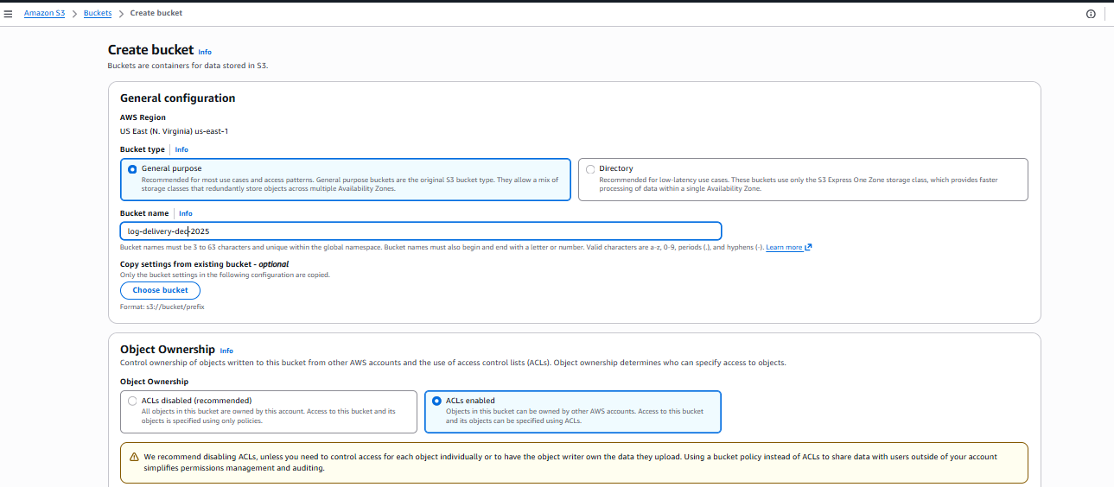
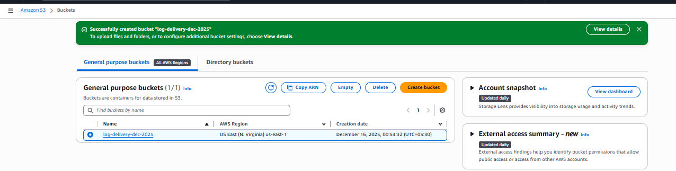

Configure Bucket Policy
Added policy to allow ELB log delivery service:
- logdelivery.elasticloadbalancing.amazonaws.com
- Permissions:
  - s3:PutObject on AWSLogs/<account-id>/*
  - s3:GetBucketAcl
  - s3:ListBucket
This ensures ALB can write logs to the bucket.

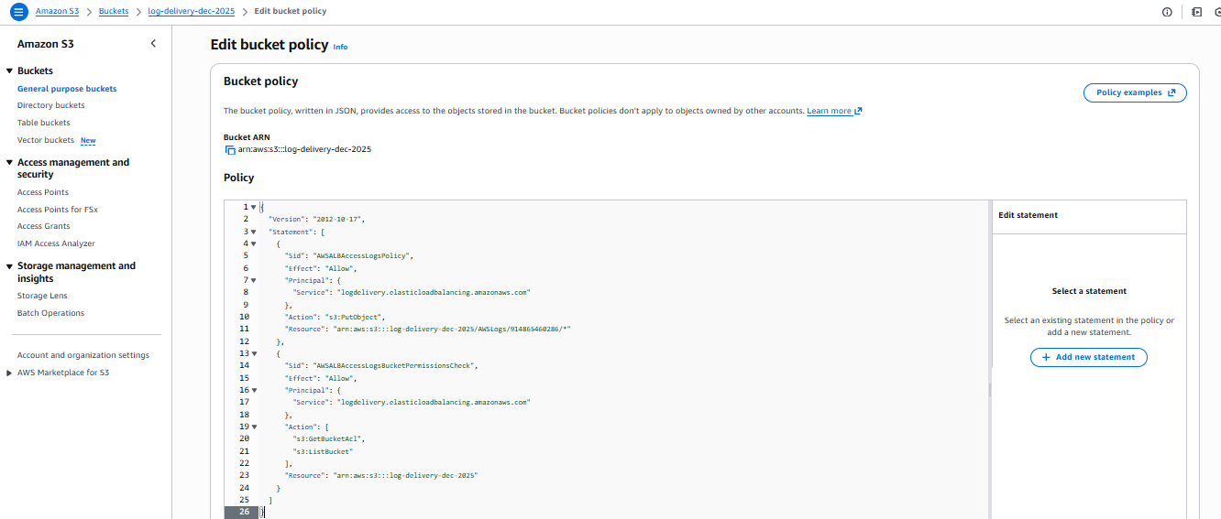

Enable ALB Access Logs
- Navigate to EC2 → Load Balancers → SSL-ALB
- Edit Attributes
- Enable Access logs
- S3 location set to:
- s3://log-delivery-dec-2025
- Save changes

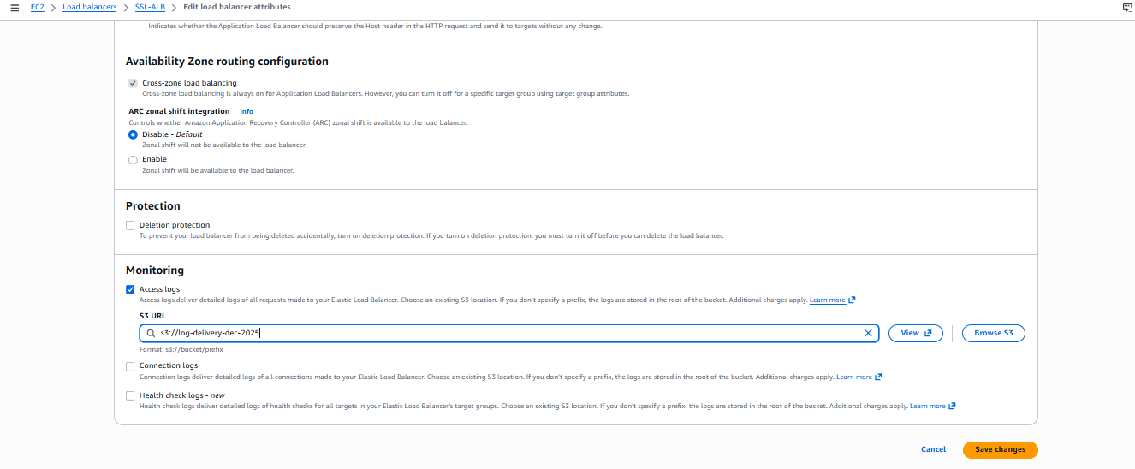
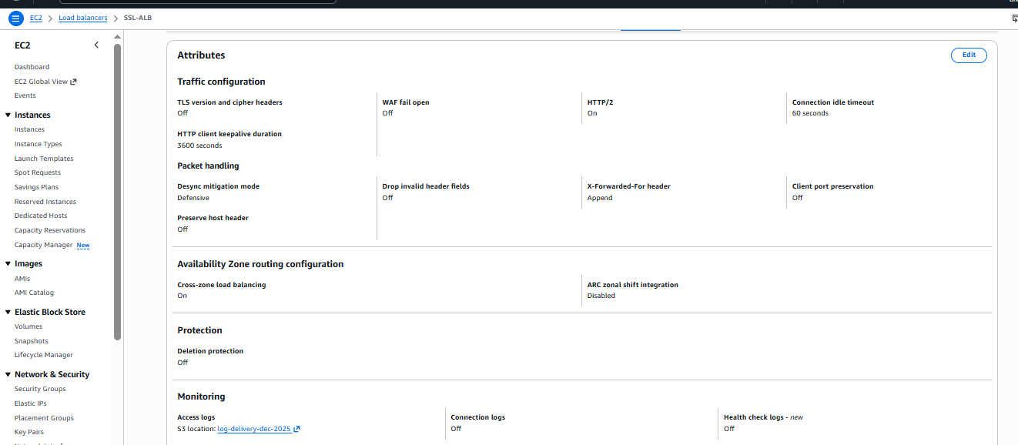

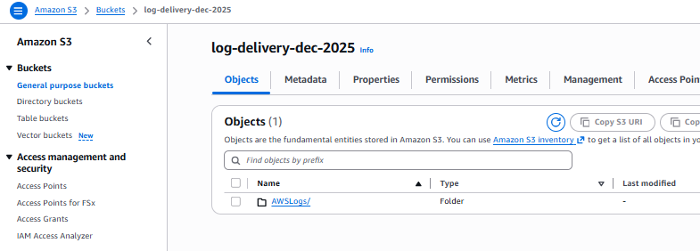
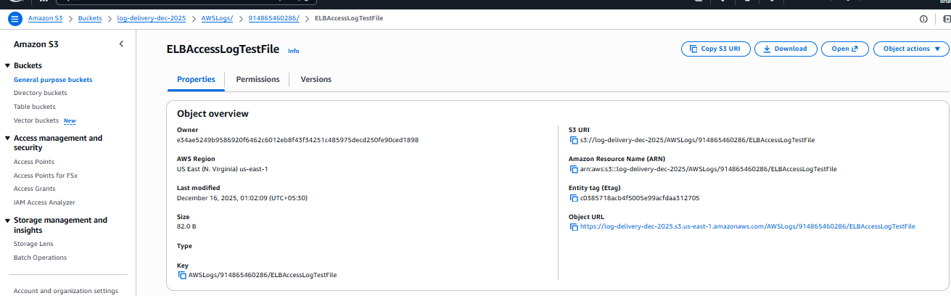

Validation Steps

✅ Bucket Creation
- Bucket log-delivery-dec-2025 successfully created.

✅ Log Folder Creation
- AWSLogs/ folder automatically created in S3.

✅ Log File Delivered
- Object present:
- AWSLogs/<account-id>/ELBAccessLogTestFile
- Confirms successful write access from ALB.

✅ ALB Attributes Check
- Access logs: Enabled
- S3 bucket correctly referenced.

Issues Faced
- None observed.
- Configuration completed without permission or delivery errors.

Conclusion
The Application Load Balancer is successfully configured to deliver access logs to Amazon S3. Log delivery has been validated by the presence of the ELBAccessLogTestFile in the expected S3 path, confirming proper bucket policy and ALB configuration.

